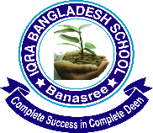
Dear parents/students,
As-salamu Alaikum Wa Rahmatullahi Wabarakatuhu…….

This is to inform you that the school will remain closed on Sunday the 10th November-2019 for Eid-E-Milad-Un-Nabi. The school will resume its classes on Monday the 11th November- 2019, Insa Allah

Principal/ Vic-Principal

